SHOPEZ : E-commerce Application
1. INTRODUCTION
Project Title
ShopEZ – MERN Stack E-Commerce Application
Developer:Vantipenti Shravani Reddy
Introduction
ShopEZ is a full-stack e-commerce web application developed using the MERN Stack (MongoDB, Express.js, React.js, and Node.js). The application provides a complete online shopping platform where users can browse products, add items to their cart, place orders, and track their purchases. The system also includes an Admin Dashboard that allows administrators to monitor products, orders, users, and revenue statistics.
The project demonstrates the implementation of modern web development technologies and follows a client-server architecture with MongoDB as the database.

2. PROJECT OVERVIEW
Purpose
The primary purpose of ShopEZ is to provide a user-friendly online shopping platform that simplifies product browsing, ordering, and management processes.
Objectives
- Develop a complete e-commerce platform.
- Implement secure user authentication.
- Provide product search and filtering.
- Enable shopping cart functionality.
- Implement order management.
- Provide an admin dashboard for analytics.
Key Features
Customer Features
- User Registration
- User Login
- Product Browsing
- Product Search
- Category Filtering
- Add to Cart
- Remove from Cart
- Place Order
- View Orders
- Profile Management
Admin Features
- Admin Dashboard
- View Total Products
- View Total Orders
- View Total Users
- Revenue Monitoring
- Product Management

3. SYSTEM ARCHITECTURE
Architecture Overview
The ShopEZ E-Commerce Application is designed using a three-tier architecture, which consists of the Frontend Layer, Backend Layer, and Database Layer. This architecture helps in maintaining a clear separation of responsibilities, making the application more scalable, maintainable, and efficient.
The Frontend Layer is developed using React.js and Vite, providing a responsive and user-friendly interface for customers and administrators. It is responsible for displaying products, handling user interactions, managing navigation, and communicating with the backend through API requests. Technologies such as CSS are used for styling, Axios is used for API communication, and React Router DOM is used for navigation between pages.
The Backend Layer is developed using Node.js and Express.js. It acts as the core processing unit of the application and handles all business logic. The backend is responsible for user authentication, product management, cart operations, order processing, and handling API requests from the frontend. It processes user actions and communicates with the MongoDB database to retrieve or store information.
The Database Layer uses MongoDB to store and manage application data. It maintains separate collections for users, products, cart items, and orders. MongoDB provides flexible and efficient data storage, enabling quick retrieval and management of information required by the application.
The workflow of the system begins when a user interacts with the React frontend. The frontend sends requests to the backend using Axios. The backend processes these requests using Express.js and Node.js, performs the necessary operations, and communicates with MongoDB to retrieve or update data. The processed information is then sent back to the frontend, where it is displayed to the user.
This architecture ensures smooth communication between all components of the system while providing a reliable and scalable platform for online shopping and administrative management.

4. SETUP INSTRUCTIONS
Prerequisites
Before running the application, install:
- Node.js
- MongoDB
- VS Code
- Git
Installation Steps
Clone Repository
git clone <repository_url>
Install Frontend Dependencies
cd client
npm install
Install Backend Dependencies
cd server
npm install
Start Backend Server
npm start
Start Frontend Server
npm run dev
Frontend URL:
http://localhost:5173
Backend URL:
http://localhost:5000

5. FOLDER STRUCTURE
ShopEZ
│
├── client
│ ├── public
│ ├── src
│ │ ├── assets
│ │ ├── pages
│ │ ├── services
│ │ ├── App.jsx
│ │ └── main.jsx
│
├── server
│ ├── models
│ │ ├── User.js
│ │ ├── Product.js
│ │ ├── Cart.js
│ │ └── Order.js
│ │
│ ├── seed.js
│ └── index.js

6. RUNNING THE APPLICATION
Frontend
cd client
npm run dev
Backend
cd server
npm start
The frontend communicates with the backend through REST APIs and data is stored in MongoDB.

7. API DOCUMENTATION
User APIs
Method | Endpoint | Description
POST | /register | Register User
POST | /login | Login User

Product APIs
Method | Endpoint | Description
GET | /products | Get Products
GET | /products/:id | Get Product Details

Cart APIs
Method | Endpoint | Description
GET | /cart | View Cart
POST | /cart | Add to Cart
DELETE | /cart/:id | Remove Product

Order APIs
Method | Endpoint | Description
POST | /orders | Place Order
GET | /orders | Get Orders

Admin APIs
Method | Endpoint | Description
GET | /dashboard | Dashboard Statistics
GET | /orders | View Orders

8. AUTHENTICATION
The application provides authentication using:
- Registration System
- Login System
- Role-Based Access Control
User Roles
Role | Access
Customer | Products, Cart, Orders
Admin | Dashboard, Analytics
The user role is stored in MongoDB and used to control access to admin pages.

9. USER INTERFACE
Login Page
Allows users to log in using email and password.

+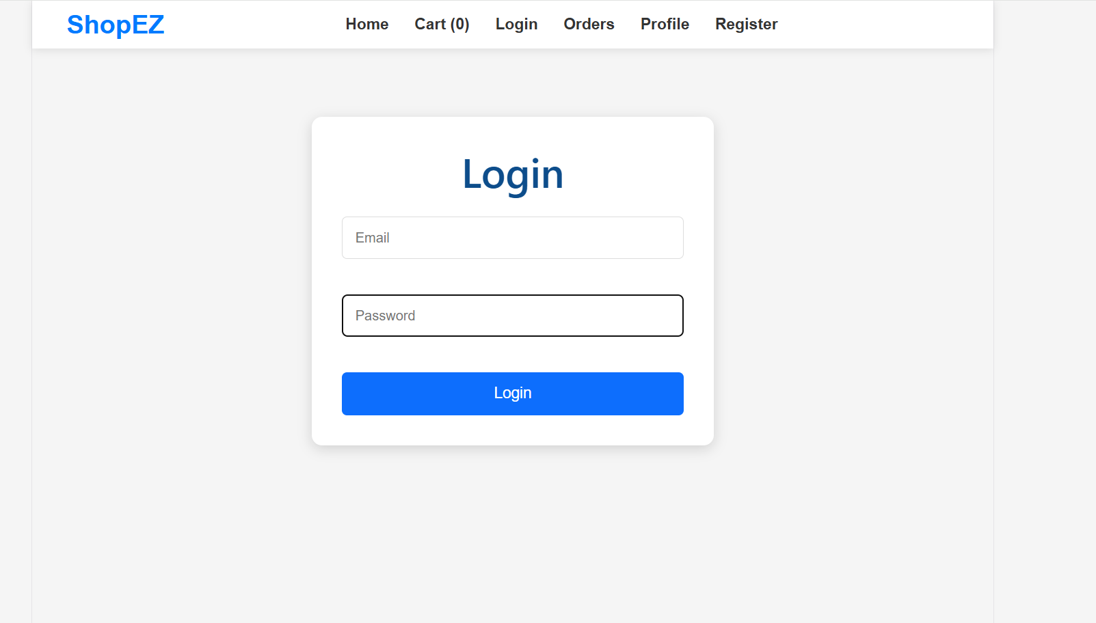

Registration Page
Allows new users to create an account.
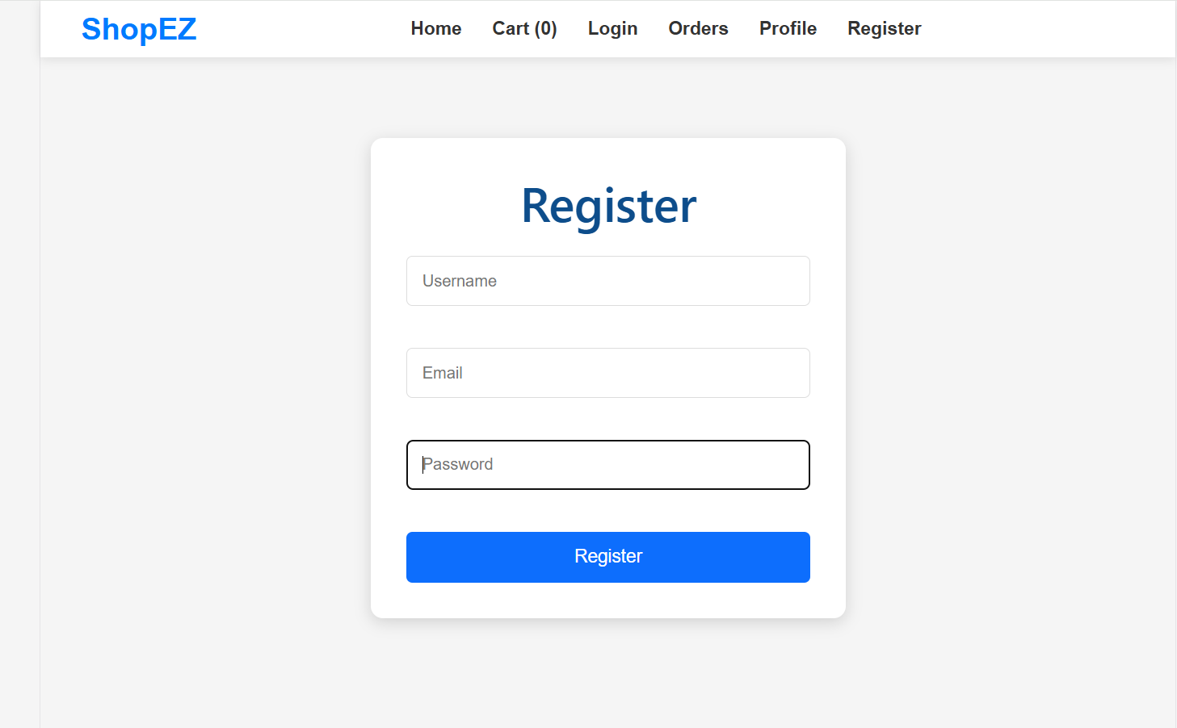
Home Page
Displays products categorized under:
- Electronics
- Beauty
- Cricket
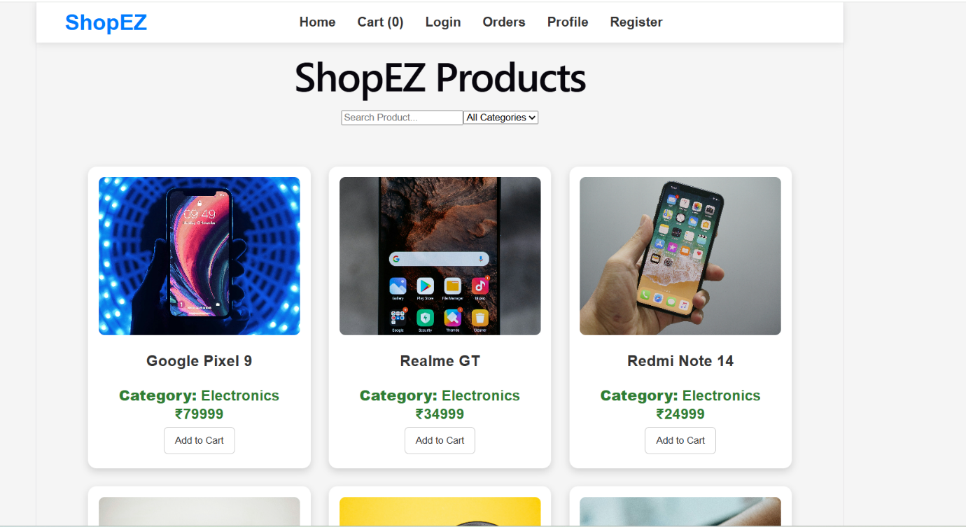
Cart Page
Allows users to:
- View cart items
- Update quantity
- Remove products
- Place orders
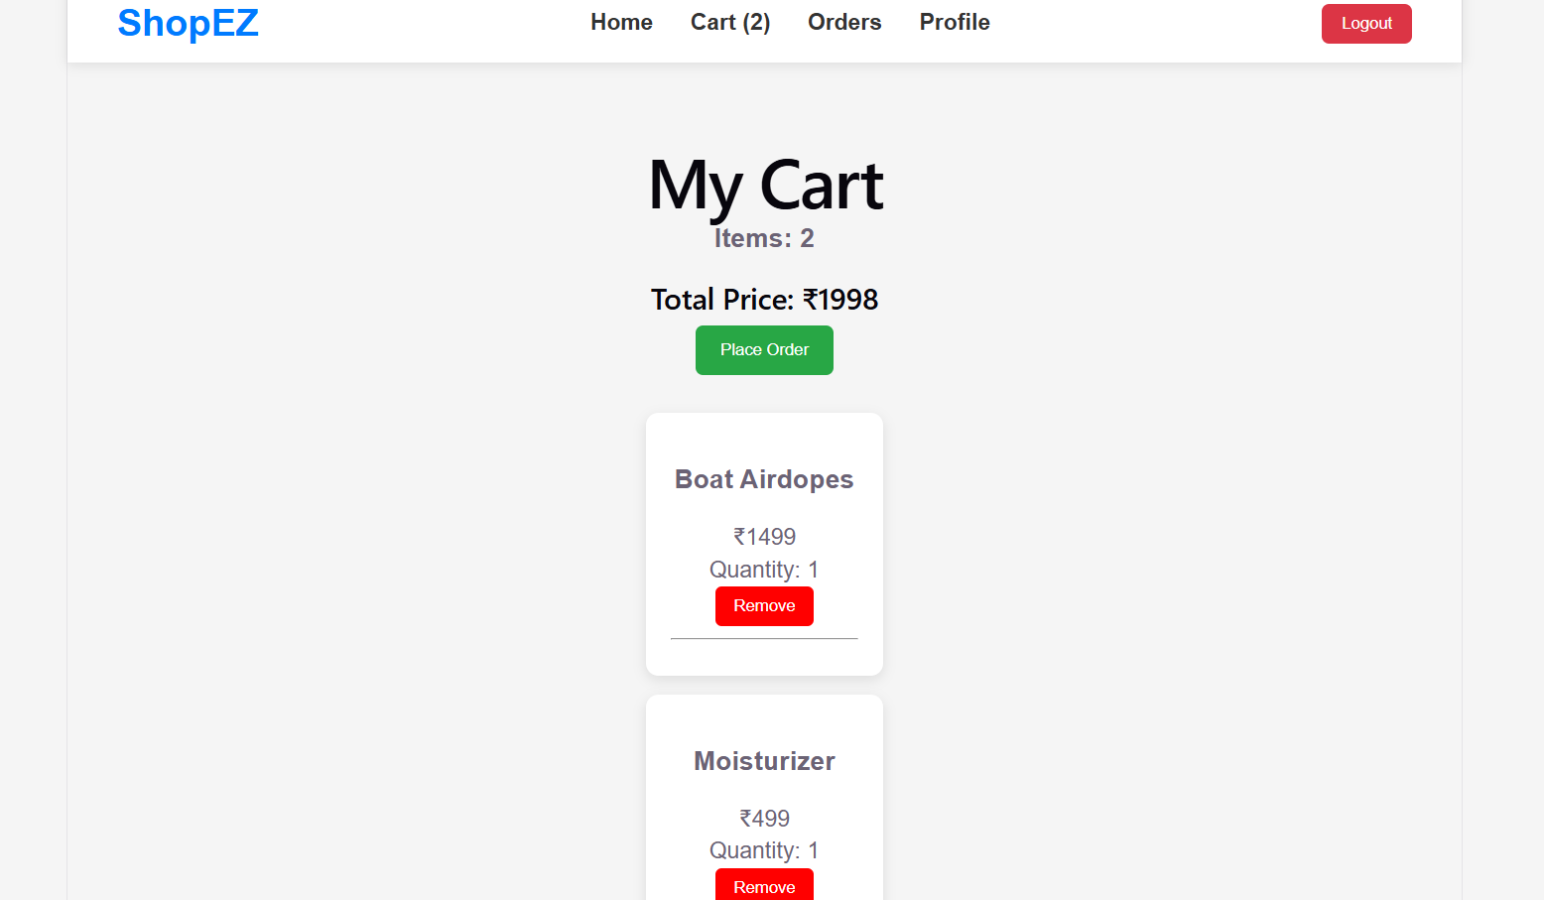
Orders Page
Displays previous orders with order status.
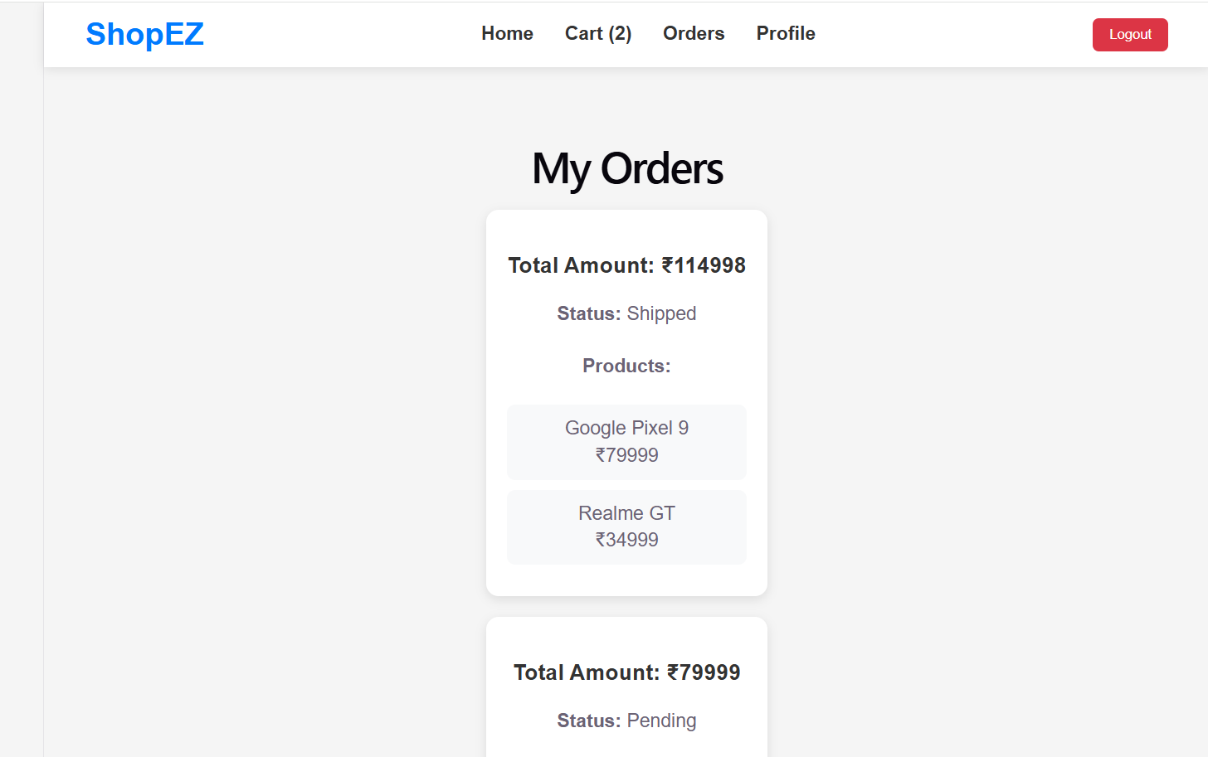
Profile Page
Displays user details.
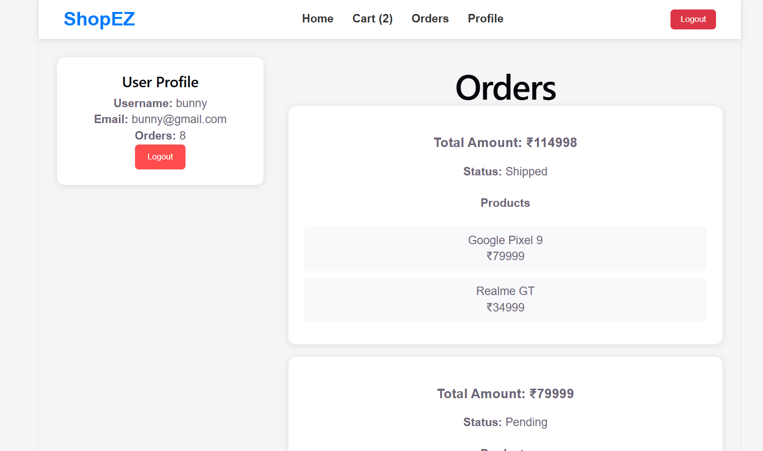

Admin Dashboard
Displays:
- Total Products
- Total Orders
- Total Users
- Total Revenue
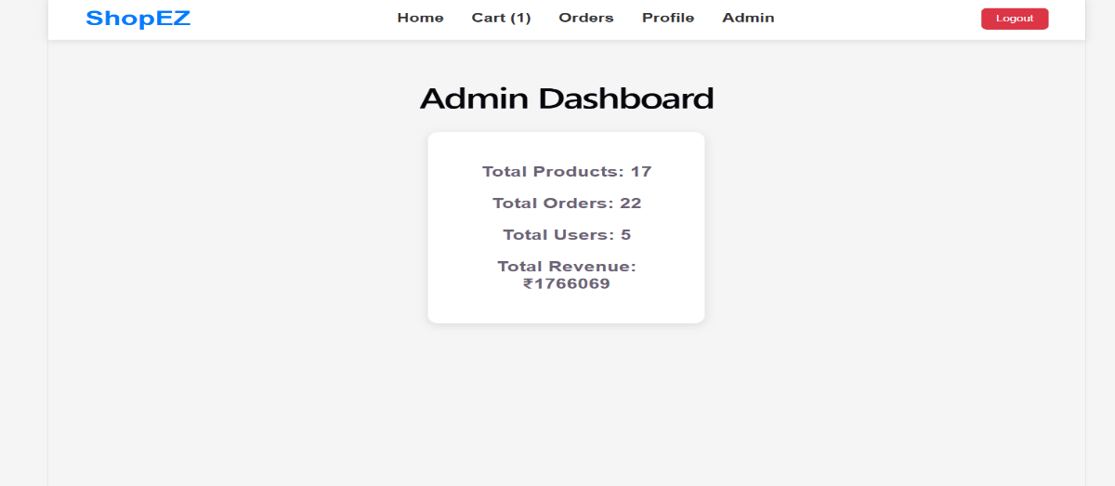

10. TESTING
Testing Strategy
Manual testing was performed to verify system functionality.
Test Cases
Test Case | Expected Result | Status
User Registration | Account Created | Pass
User Login | Login Successful | Pass
Product Loading | Products Displayed | Pass
Add to Cart | Cart Updated | Pass
Remove Product | Product Removed | Pass
Place Order | Order Created | Pass
View Orders | Orders Displayed | Pass
Admin Dashboard | Statistics Loaded | Pass

11. SCREENSHOTS / DEMO

- Login Page

- Register Page


- Home Page


- Cart Page


- Orders Page

- Profile Page


- Admin Dashboard
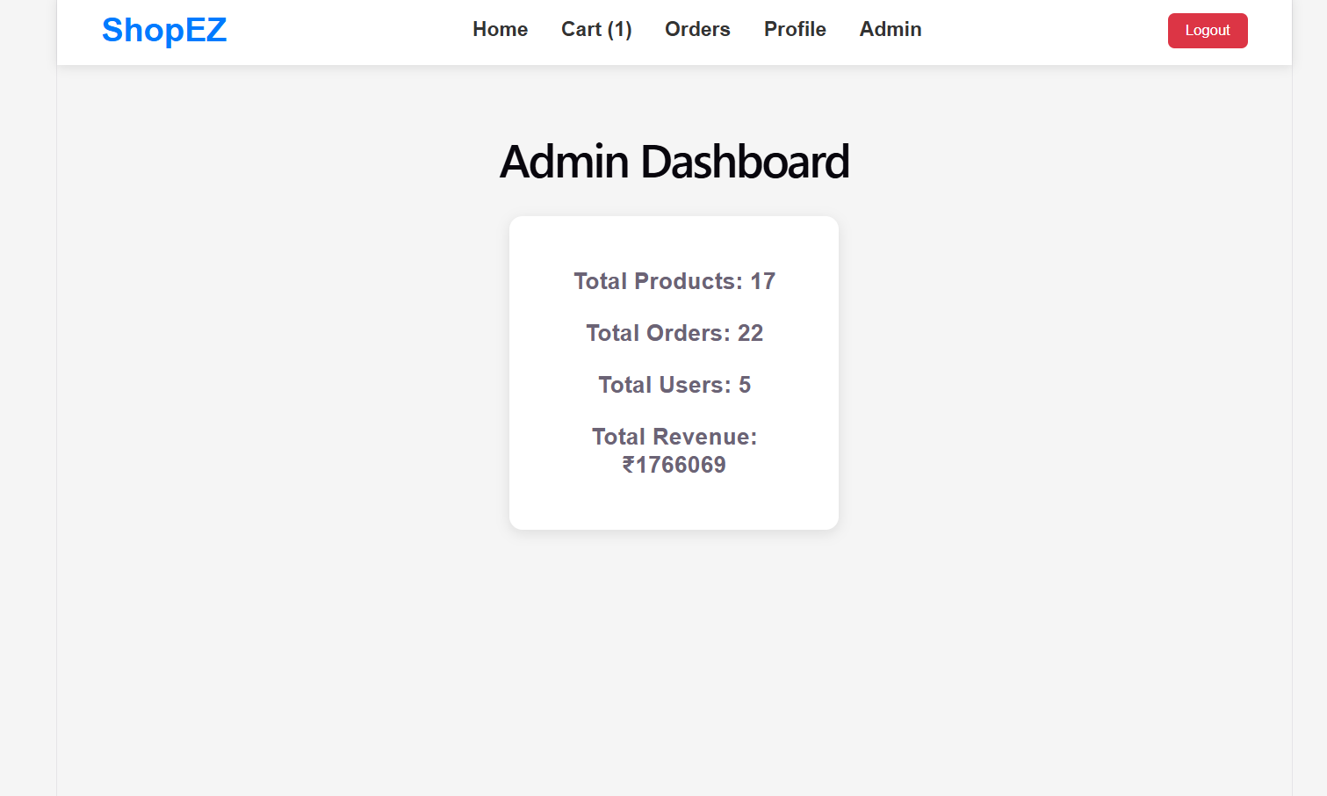
- MongoDB Collections
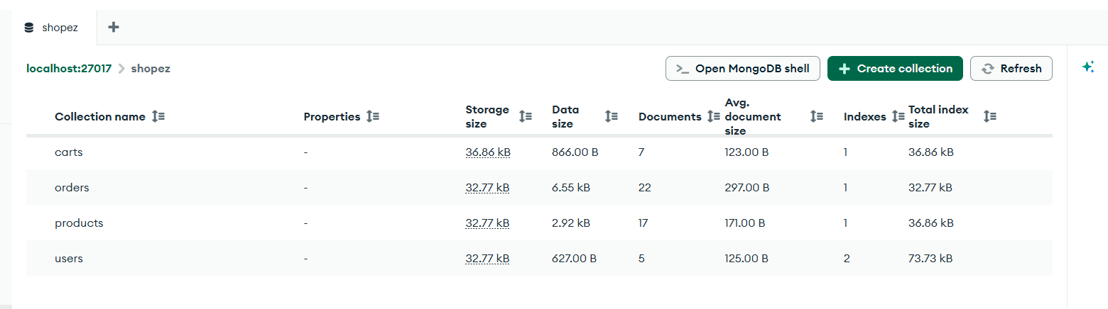

12. KNOWN ISSUES
S.No | Issue
1 | Customer name not displayed in order history
2 | Payment Gateway not integrated
3 | Email verification not implemented
4 | Password encryption can be improved

13. FUTURE ENHANCEMENTS
S.No | Enhancement
1 | JWT Authentication
2 | Online Payment Integration
3 | Product Reviews
4 | Wishlist Feature
5 | Email Notifications
6 | AI-Based Recommendations
7 | Inventory Management
8 | Mobile Responsive Design Improvements

CONCLUSION
ShopEZ successfully demonstrates the implementation of a full-stack e-commerce application using the MERN Stack. The project integrates React.js for frontend development, Node.js and Express.js for backend services, and MongoDB for database management. The application provides a seamless shopping experience with product browsing, cart management, order processing, and administrative analytics. The project showcases practical implementation of modern web development technologies and fulfills the objectives of a complete e-commerce platform.

